Recap of the D Network Meetings 27-29 April, 2018.

Here is the recap of what we discussed last weekend at the D Network Meeting (27-29 April). I have outlined the major decisions and included relevant references, resources and step by step process.
- What is discipleship?

After much deliberation we all have agreed to accept the below discipleship expression.
Please see the attached Document - Discipleship the heart and purpose.
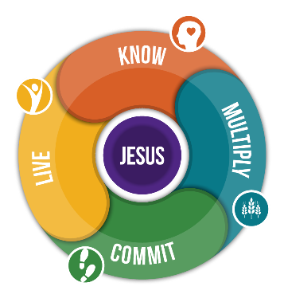

Jesus is the centre of what we believe – what we do – what we are.

It’s critical that every disciples has the Gospel Picture of God. See, “No one has ever seen God, but the one and only Son, who is himself God and is in closest relationship with the Father, has made him known.” John 1:18 NIV

We believe that it is by experiencing God (KNOW) in our life and by belonging (LIVE) to God’s family we can grow (COMMIT) spiritually and be motivated to share (Multiply) Jesus with others.

We affirmed that to go ahead with the discipleship journey we must work within movement framework. Please see the attached power point (2 - Session - Movement Framework) explaining the values of a movement and the differences it has compared with an organisation.

- What is a disciple?
After much deliberation we agreed that we view a disciple as any person who
…while becoming more like* Jesus, makes** disciples.

*Galatians 5:22-23; 1 John 4:20; John 13:35.
** John 15:8.

Outcome:
We agreed that our ultimate outcome in our churches and in all we do is to see members who, while becoming more like Jesus, make disciples.

- What will secure the above outcome?
After much deliberation we all agreed that to see our members becoming like Jesus and making disciples we need to secure the below outputs. For the outputs – what they are why we are talking about them, see the attached Word Document called, 4 - Session Developing D process based on D Outcomes.
Remember we don’t plan for activities and resources UNTIL we know WHAT our outcomes and outputs are. In other words, we start with the end in mind and plan backwards.

See this power point attached.

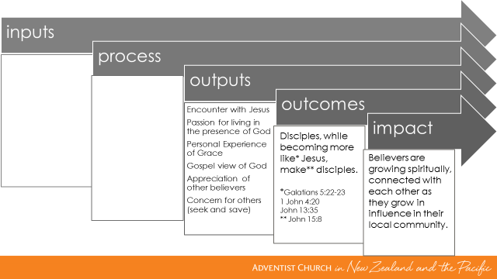

- Process
As we all agreed we are dealing with much deeper issues than behavioural and even belief adjustments. We are dealing with a deep change that involves a change of the World View as shared by Hatsar.

See the Document you received from Hatsar.
We agreed that we will not be able to see genuine Discipleship Journey without our people changing their Worldview.

We agreed that ultimately it’s the work of the Holy Spirit. At the same time we recognised that the Holy Spirit is working today and if we facilitate space in time for this change to take place, it will take place.

From what I shared we affirmed there are 3 factors that shape our Worldview as we grow.

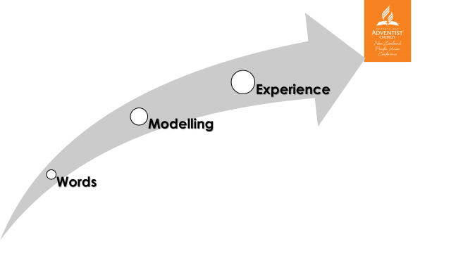

The words we hear from our parents, guardians and role models shape our thinking of what is true and what’s not. We closely observe their modelling – life choices etc… and it all leads us to our own experiences.

We affirmed that in our approach to discipleship we need to be aware of these factors.
Example: Our Sermons, Key Messages we communicate to our members will slowly shape their thinking. Our Modelling (what we do and how we handle ministry and life) WILL most definitely affect them. Also, we need to think about spaces where people can experience God, Community, and Witnessing etc…

With this in mind I suggested that our process should sit on the three simple principles below that may need to shape our ministry. They will need to be facilitated simultaneously for greater impact.

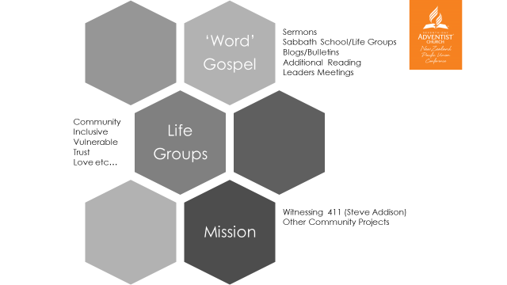

Word

By ‘Word’, I don’t just mean preaching. We will need to be very creative in designing a channel in our churches by which our people will get the ‘right’ kinds of ideas.

Sermons is, obviously, one of the main channel. Also, consider creating a handout for your sermons with a short summary and 3 questions for people to take home to reflect and even some can discuss them at their life groups.

Blogs and Bulletin articles – Consider placing a short 300 words paragraph on discipleship once a week. Communicate discipleship values.

Use your Facebook Page to post a thought for a day or a week.

Remember the outcome we work towards: It’s not behaviour adjustments but encounter with Jesus, Passion for being in God’s presence, etc…

Here is the support you will get from us.
We would like to launch a Journey with Jesus campaign that will go for 12 months. That means:
- Hands on training and mentoring which will assist you in developing a good strategy for the WORD focus.
- We suggest that you preach from the Gospels – pure stories of Jesus, His parables, His miracles etc… See, “For I resolved to know nothing while I was with you except Jesus Christ and him crucified.” 1 Corinthians 2:2.
- We have developed a resource called, Journey with Jesus’ where people are encouraged to spend Time with God being Transparent and Vulnerable so they can see God’s love and submit to Him. It has a self-reflection tool to meditate upon their personal journey with Jesus.
- Use Peter Roenfeld’s book for life groups. The books will be provided for you and your leaders for free.
- Use Peter’s or Steve’s method of reading the Gospel in your life groups. Remember – they are not Bible Study Groups – they are Life Groups. Peter and I will facilitate a webinar very soon. You can use the Sabbath School time to do it too. Some churches are doing it quite successfully.
- We will provide a number of good sermons to that will unpack the heart of a Journey with Jesus.
- We have produced 8 short videos unpacking what discipleship is and how one can grow spiritually. We will be producing at least 12 of new ones every year.
- We started to produce life stories of people whose life was changed as they met other members who showed them the love of God. We will have at least 6 of them every year.
- We will write good weekly blogs to get key messages across.
- Support in person or via Zoom in your monthly Leaders Meetings for the purpose of communicating the Discipleship Values and developing Discipleship Process in your church.

Expected Outcome:
People have:
- the Gospel view of God
- Passion for living in the presence of God
- Encounter with Jesus

Life Groups
Please remember Life Groups are NOT Bible Study Groups. These groups, at their core, have a focus on people’s life journey, fellowship where a community is taking place.
I strongly suggest that you yourselves start a life group and then plant another group. Please don’t launch ‘total member involvement’ in groups for all members! You will be back to the organisation approach.
Sabbath School time can be successfully utilised so long the groups don’t waste their time on combined preliminaries but go to their groups right away. If you do it during the Sabbath School time you really need to guard the time. For a great group dynamic to take place you need to allow 1 hour and 30 min.
Here is the support you will get from us.
As mentioned before we would like to launch a Journey with Jesus campaign that will go for 12 months. Life groups are a part of this journey. We would like people to have space to create a community where their faith can grow. The truth of the matter discipleship growth cannot take place in isolation, it must have a community.
- Use Peter Roenfeld’s book for life groups. The books will be provided for you and your leaders for free.
- We will offer a webinar with Peter who will cover his Gospel reading method
- We will offer a webinar of community development
- We will provide resources and sermons of Community Development

Expected Outcome:
People have:
Appreciation of other believers
An authentic community where they belong
Most members have at least 6 meaningful friends
Mission
As we discussed the challenge is in moving forward in the 3 areas (Word, Life Groups and Mission) simultaneously.
Remember we don’t need to train and train people and hope that someday they would witness. If we have a training on 411 then we must plan to go out on the same day. Or if you give people a task to share with their neighbours, then gather them after they have done it (maybe in a week) and ask to share, see Luke 10.
There are three levels of sharing and witnessing:
- My Oikos – people close to us
- Loose connections – people we meet randomly
- Looking for a person of peace - witnessing in streets

The above and more strategies are available in the training Steve shared.
You can think about Community Service Projects etc…

Here is the support you will get from us.
We would love to see the 411 method being trialled in different settings. Steve and I would like to offer ongoing coaching and mentoring in this area. We will invite you to join us via Zoom and Webinars.
We are currently producing S.H.A.P.E training focusing on spiritual gifts, passion, abilities of people so they can better serve their church and community.
Also we have huge support from Adventist Health and ADRA. They are willing to come to train and provide all resources FREE for you. They have money and are willing to give a priority to the Discipleship Network Churches.
Creation Health Programme
Stop Smoking
ADRA has at least 5 great programmes you can run with some money they can give you.
Family focus programme for your community can be run by Victor and his team too.
Expected Outcome:
People have:
Concern for others
10-20 lives changed as a result of the Mission focus
- Sustainability Issue

We discuss the issue of sustainability. We have started many projects, many initiatives and then they faded away as we got busy. I shared my 100% unswerving commitment to this Vision. For me, it’s where everything rises and falls. I believe in God’s Vision for this movement and I’m going to press on with any pastor until we see good outcomes. I have done it in my personal ministry before in a number of settings and I believe it will work here too.

An issue of churches already having to do a lot was discussed. Remember, this movement cannot be an add-on to what you are doing. We agreed that it is the very heart of a church life. Remember, Less is More.

With that in mind, we discussed that to refocus your church you will need at least 3 months to communicate this Vision to your leaders, your church members to ensure 100% Clarity. Then you will move to Construct stage of realignment where you might need to adjust what programmes your church will run and what programmes your church will need to drop etc… Then your church will be operating (Cruise) in that mode while getting a lot of feedback from all levels to adjust as required.

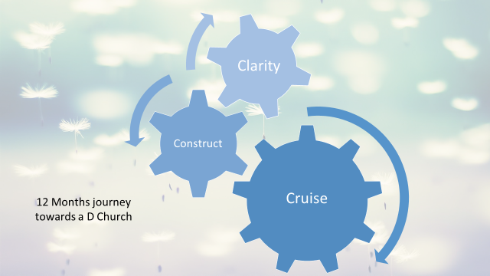

So, to ensure that we track along, we discussed the below chain of connecting points where this Vision will be discussed, developed further and trialled.

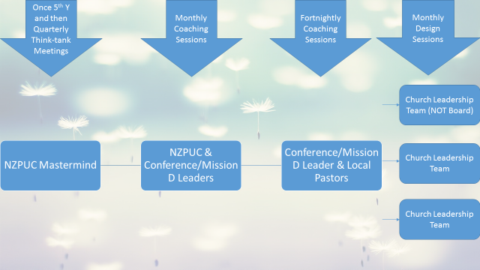

We discussed the format of the coaching session. It is below. Remember coaching doesn’t mean a top down hierarchy but a buddy support and accountability partnership. We will be offering training on coaching process.

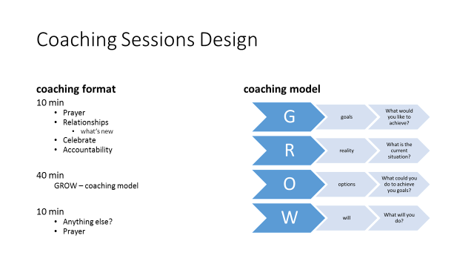
- Going forward
We discussed these progressive outcomes we would like to see in our churches.
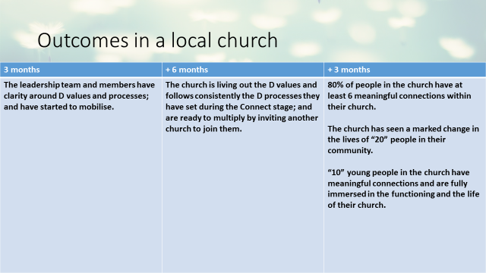

Allow me to break it down into a 3 months goal, see below. We will continue to develop it further together as the time goes by. At this stage, let’s focus on the first 3 months.

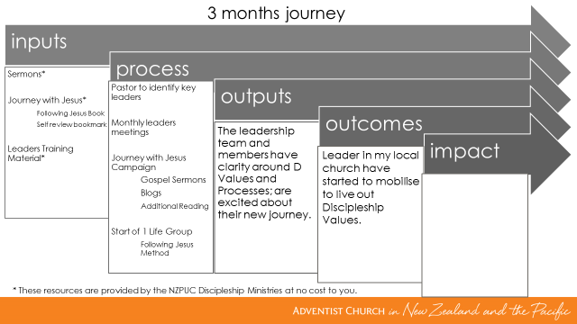
- First steps – Summary
  - The first step for you to take as you start is to PRAY. Yes, pray so God can show the church you can focus on, if you have more than one. Pray so you can see those key people who can journey with you and who you can invite to your life group and the leaders meetings.
  - Second step, call for an open board-leaders meeting where you will present the ugly reality of where our church is when it comes to the losses, quality of relationships and mission focus.
  - Third step, call for a 3 months season of prayer for the purpose of seeking the Lord, capturing His Vision for His Church in Nelson, Royal Oak, Auckland, Rorotonga, Morea etc…
  - Express your unswerving commitment to being a disciple of Jesus who is becoming like Him and seeing all members being growing Disciples.
  - Appoint your first leaders meeting where you will be discussing and developing a NEW discipleship process.
  - Start preaching about these issues going deep all the way to change the worldview NOT behaviour and just mental beliefs.
  - Start a model life group.
  - Plan for the second stage of the process. We will be working on it together.

Final Comments:
As I have shared with you, I’m 100% committed to this journey and I intend to stick to it without allowing other good programmes, events and committees to side-track me. For me, it is where everything in Discipleship journey rises and falls – it is where the ‘rubber meets the road’.
Honestly, I’m very tired of talking about Discipleship. I would like to see God in action in this space. I’m totally convinced that this is the space God wants me to work on. He is truly casting (ἐκβάλλει); literally, driveth him forth – see Mark 1:12) me into this. I can’t resist.
We can continue to talk and preach about discipleship models, concepts and ideas until Jesus comes. I bet to differ! I choose to preach less and do more being practical.
You don’t have to follow it if you feel that God is leading you in a different direction, or you are not ready or for any other reasons.
On the other hand, if you do stay on the Discipleship Network and consistently follow the process you have my 100% commitment to support you in all you need to succeed.
I’m very happy to fly over and meet with you, your leadership team and your church to ensure 100% traction.
The two main Biblical mandates we hold are:
“Follow Me, and I will make you fishers of men.” Matthew 4:19 ANS
“…what you have heard from me in the presence of many witnesses entrust to faithful men, who will be able to teach others also.” 2 Timothy 2:2 ESV

Victor Kulakov
NZPUC Discipleship Ministries Leader
+64 9 2501770
http://disciple.org.nz

